LifeHub

**Main Project – Group 2**

**LifeHub**

Jiamin Luo (8986565)

Nhi Ha Thao Nguyen (9022701)

Gargi Dipen Dave (8966699)

Kurians Mathew (8941633)

Computer Applications Development, Conestoga College

INFO8003: Systems Concepts, Analysis and Design

Randall Kozak

10 December 2024

**Introduction** 3

**Using a collaborative tool** 3

**Forming a Development Team** 4

**Brainstorming** 5

**Research** 5

**Description** 9

**Technical Requirements** 11

**Personas** 13

**Use Case** 16

1. **Use case diagram** 16

**2.** **Use case description** 18

**Activity Diagram** 20

**Entity** 21

**Content Plans** 25

**1. Community Engagement (Forum)** 25

**2. Centralized Platform** 26

**Class Diagram** 27

**Prototype** 28

**Agile Plan** 34

**Conclusion** 38

**Appendix** 39

# **Introduction**

In today's fast-paced world, people are always searching for effective, efficient solutions to meet their everyday demands. Users frequently find themselves juggling various apps or platforms, whether they are looking for a trustworthy apartment sublet, a carpool for their commute, or a good deal on used goods. Although there are numerous apps that address these distinct demands, very few provide a single, cohesive solution that combines all these features into a smooth user experience. Here's where our new app can help.

Our goal is to develop a comprehensive platform that integrates apartment subletting, carpooling, buying and selling used goods, and more into a single app. This app's comprehensive experience will enable users to access a variety of services with a few clicks, eliminating the need to download separate apps for each purpose. The app's primary goal is to encourage community involvement by making sure that users can rely on and trust one another. The app's integrated user profiles, reviews, and ratings foster confidence and assist users in making wise choices. Additionally, it offers smooth in-app payment choices with an extra degree of oversight, guaranteeing safe and dependable transactions amongst users. Whether you're a renter, landlord, commuter, or a deal hunter, our app offers the resources you need to interact with people in a reliable and user-friendly manner.

# **Using a collaborative tool**

Repository Link: <https://github.com/Joy-LJM/System-Concept-Main-Project>

# **Forming a Development Team**

|  |  |  |  |  |
| --- | --- | --- | --- | --- |
|  | Kurians (Developer) | Gargi (Product Owner) | Nhi (Developer) | Jiamin (Scrum Master) |
| Brainstorming |  |  |  | ✔ |
| Research |  |  |  | ✔ |
| Business Model |  | ✔ |  |  |
| Market Analysis and Personas |  | ✔ |  |  |
| Use Cases |  | ✔ | ✔ | ✔ |
| Entity Relationship Diagram |  |  | ✔ |  |
| Class Diagram |  |  |  | ✔ |
| Content Plans | ✔ |  |  |  |
| Prototype Mock-ups |  |  | ✔ |  |
| Code Development |  |  | ✔ | ✔ |
| Testing | ✔ | ✔ | ✔ | ✔ |
| Documentation | ✔ | ✔ | ✔ | ✔ |

# **Brainstorming**

Create a unified platform where users can share and discover various types of information such as carpool services, great deals, second-hand items, and apartment sublets and so on. Using this app, commuters can look for carpooling options, individuals want to buy or sell second-hand items, renters or landlords look to sublet or find tenants. In current market, while there are apps covering parts of these functions, few integrate all these functionalities seamlessly. The app focuses on community engagement, usability, and trust. So, in order to combine these features into one app, help the users saving time without downloading related apps to find a carpool or sublet, provide in-app payment options by supervision, it could fill a gap in the current market.

# **Research**

At first, after researching the field of application, there are some existing apps with similar features. Like Craigslist, Facebook Marketplace, BlaBlaCar, Nextdoor.

1. Craigslist: [https://www.craigslist.org/about/sites](https://www.craigslist.org/about/sites%20)

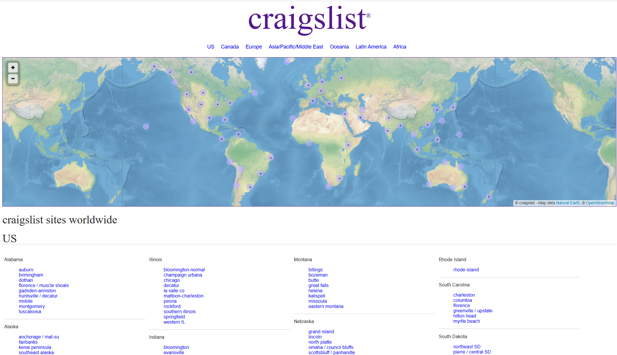

1. Facebook Marketplace[： https://www.facebook.com/marketplace/](：%20https:/www.facebook.com/marketplace/)

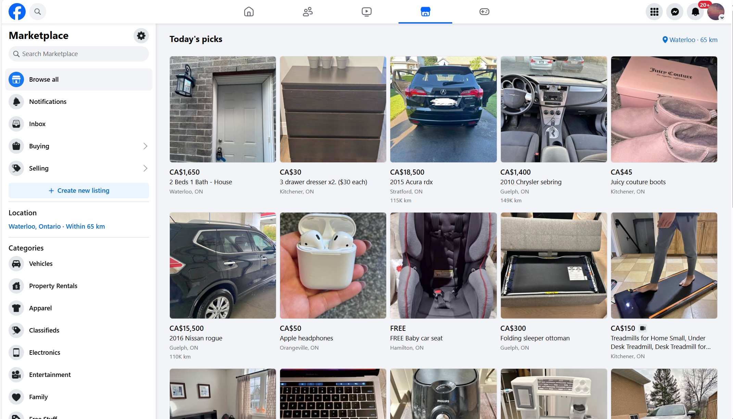

1. BlaBlaCar: <https://www.blablacar.co.uk/>

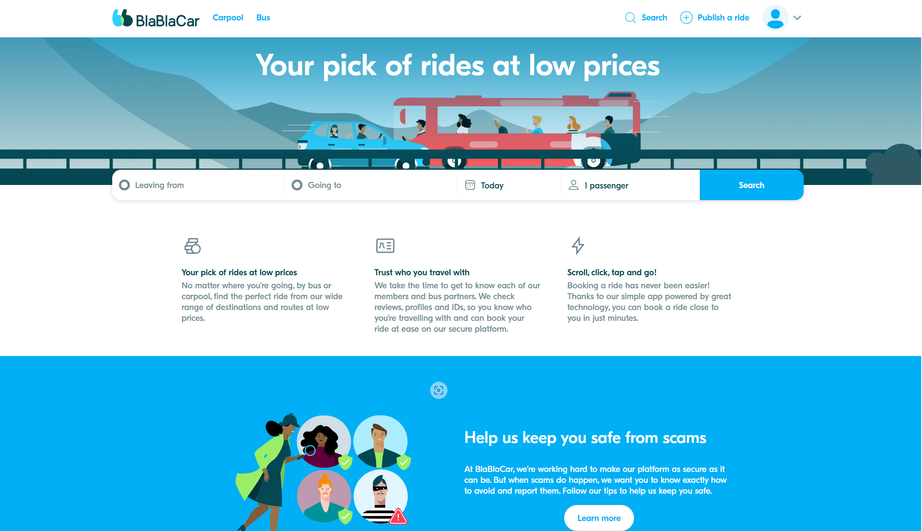

1. Nextdoor: <https://nextdoor.com/>

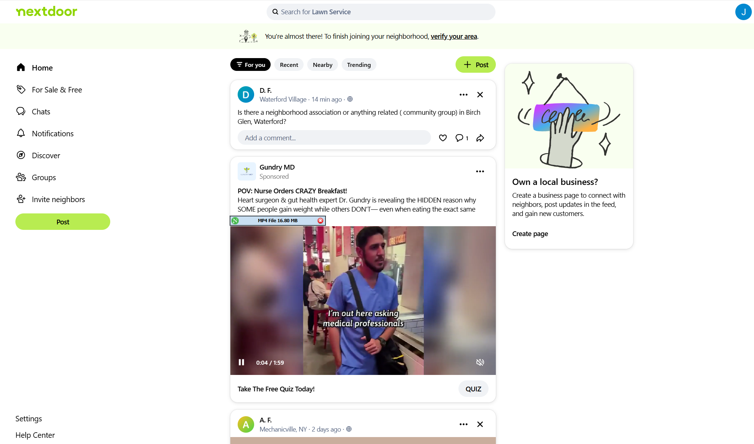

As for people use now to accomplish the same goals, these are the points:

* General Platforms: Facebook, WhatsApp groups, Craigslist.
* Specialized Apps: The apps listed above, though they are fragmented across use cases.

Challenges with Current Solutions:

* Lack of centralization.
* Limited trust mechanisms (e.g., Craigslist).
* Few tools for community-building or hyperlocal discovery.

Therefore, we dedicate ourselves to developing a centralized app with the below features:

1. **Centralized Platform:** Integrate carpooling, item sales, deals, and sublets into one app.
2. **Hyperlocal Focus:** Location-based features for better personalization.
3. **User Trust & Safety:** Verified accounts, user reviews, and content moderation.
4. **Categories:** Allow users to filter and browse through specific categories like carpooling, deals, etc.
5. **Real-time Communication:** In-app messaging and notifications for timely updates.
6. **Payment Options:** Secure payment integration for transactions.
7. **Map View:** Visualize listings and services geographically.
8. **Community Engagement:** Forums or groups for discussions and sharing.

Compared with the other apps in current market, the differences are below:

1. **All-in-One Platform:**
   * Facebook Marketplace no dedicated focus on specific community-driven needs like carpooling.

* Our difference: Combines carpooling, second-hand sales, deals, and rentals, eliminating the need for multiple apps.

1. **Trust & Moderation:**
   * Facebook Marketplace has minimal moderation, lacks dedicated categories like carpooling or deals.
   * Our difference: A robust verification system for users and AI-assisted content moderation.
2. **Tailored to Local Communities:**
   * BlaBlaCar focuses solely on carpooling, without localized services or other community features.
   * Our difference: our app emphasises on hyperlocal interactions, making it easier to connect with nearby users.
3. **Dynamic Posting System:**
   * Craigslist is with outdated design and limited focus on real-time or social interaction.

* Our difference: our app can customize templates for various use cases and focus on community.

Developing this app makes sense for several key reasons:

1. **Market Gap:** No app currently integrates all these functionalities into a cohesive, user-friendly platform.
2. **Hyperlocal Demand:** A growing interest in local, community-focused apps.
3. **Convenience Factor:** Reduces the hassle of juggling multiple platforms.
4. **Scalability:** The app can grow to include other services like job postings, lost & found, or community events.
5. **Revenue Potential:** Freemium model, ads, and transaction fees offer multiple monetization opportunities.

# **Description**

**Refined Description:**

Our app serves as an all-in-one platform, simplifying the process of finding and sharing services such as carpooling, second-hand items, deals, and apartment sublets within local communities. By integrating these features into one seamless interface, the app provides a convenient and efficient solution for users, eliminating the need for multiple specialized apps. The app prioritizes trust, safety, and community engagement, with features like verified user accounts, AI-assisted content moderation, and a robust review system. It offers users the ability to search, communicate, and make secure payments for transactions all within the same platfor. Through location-based services, users can find hyperlocal opportunities, helping them connect with others nearby and fostering a sense of community.

**Business and Social Purposes:**

* **Business Purpose:** To provide a centralized platform where users can access multiple community-driven services. This reduces the friction of using separate apps for different needs and opens up opportunities for revenue generation through freemium models, ads, and transaction fees. The app's design also allows for scalability, enabling the addition of new services and features over time.
* **Social Purpose:** To build a more connected and trust-driven community, where people can easily share services and resources. By fostering safe, localized interactions and supporting the exchange of goods and services within communities, the app contributes to social cohesion and reduces reliance on larger, impersonal platforms.

**Desirable Features (Preliminary List):**

1. **Centralized Platform** for carpooling, second-hand items, deals, and sublets.
2. **Hyperlocal Focus** with location-based filtering and personalized recommendations.
3. **Trust & Safety** through user verification, ratings, and AI-assisted content moderation.
4. **Real-Time Communication** using in-app messaging and notifications.
5. **Secure Payment Integration** with transaction supervision.
6. **Map View** to visualize listings geographically.
7. **Category-Specific Filters** to browse relevant content (e.g., carpooling, sublets, deals).
8. **Community Engagement Features** like forums, group discussions, and local event sharing.
9. **Dynamic Posting Templates** for easy listings creation in various categories.

**Possible Revenue Streams:**

1. **Freemium Model:** Offering premium features (e.g., advanced filtering, priority listings) for a subscription fee.
2. **Transaction Fees:** Taking a small commission on payments processed through the app for carpooling, item sales, or rentals.
3. **In-App Advertising:** Displaying relevant ads based on users' activities and location.
4. **Feature Upgrades for Sellers:** Charging sellers for additional exposure, such as highlighted listings or featured spots in specific categories.

**Future Goals:**

1. **Expansion of Services:** Introduce new features like job postings, lost & found services, and community event listings to further centralize local interactions.
2. **Advanced Search & Matching:** Improve algorithms for better matching of users based on needs, preferences, and location, including AI-powered suggestions.
3. **Social Integration:** Allow users to connect with others through social media or invite friends, boosting the app's network effect.
4. **Sustainability Focus:** Promote eco-friendly options, such as carpooling or sharing items, aligning with global sustainability goals.
5. **International Expansion:** Adapt the platform to serve international markets, tailoring services to local needs and regulations.

**Relation to the Theme:**

The app addresses the growing demand for centralized, community-focused platforms in today's fragmented digital ecosystem. By providing hyperlocal, user-driven solutions for a variety of everyday needs, it fills a market gap, offering a unique blend of social, business, and functional purposes.

# **Technical Requirements**

**What special device hardware features would the app require, if any?**

The app primarily leverages standard hardware features already available on most smartphones and devices, such as:

* **GPS/Location Services:** For providing hyperlocal recommendations and filtering services based on the user’s current location.
* **Camera:** For users to easily capture photos of items they want to sell or post listings for rentals/sublets.
* **Microphone (optional):** For voice input or audio communication in real-time chat features.
* **Secure NFC/Payment Hardware:** If integrated, to facilitate seamless and secure in-person payments for transactions.

**What special input controls would you develop for this application, if any?**

The app’s design will prioritize usability with the following potential input controls:

* **Dynamic Search Bar with Predictive Input:** To allow users to quickly find items or services using keywords, with AI-powered suggestions.
* **Interactive Map Controls:** Users can drag, zoom, or drop pins on a map to explore or filter hyperlocal listings visually.
* **Swipe Controls:** To enable quick actions like favoriting, sharing, or skipping listings (similar to dating apps but adapted to listings).
* **Voice Commands (Optional):** For users to navigate the app hands-free, search for items, or post listings using voice input.
* **Customizable Filters:** Allowing users to adjust sliders or select dropdowns for precise filtering by price, distance, category, etc.

**What constraints or advantages to do with context are involved in this app?**

**Constraints:**

* **Dependence on Accurate Location Data:** The effectiveness of the hyperlocal features depends on reliable and precise GPS services. If users turn off location access or if GPS accuracy is low, the user experience might be affected.
* **Moderation Challenges in Diverse Communities:** Ensuring consistent safety and trust through AI-assisted moderation might be challenging in highly active regions.
* **Connectivity Requirements:** Since the app relies heavily on real-time features (e.g., messaging, updates), a stable internet connection is necessary for optimal performance.

**Advantages:**

* **Hyperlocal Relevance:** The app’s focus on location-based services strengthens user engagement and relevance, providing highly tailored content that adds value.
* **Increased Community Interaction:** By emphasizing local exchanges, the app fosters real-world connections, trust, and community growth.
* **Scalability Across Regions:** The app’s modular design allows it to be contextually adjusted for new locations, languages, and user preferences.
* **Environmental Benefits:** Encouraging resource sharing (e.g., carpooling, second-hand goods) aligns with sustainability trends, appealing to eco-conscious users.

# **Personas**

Persona #1

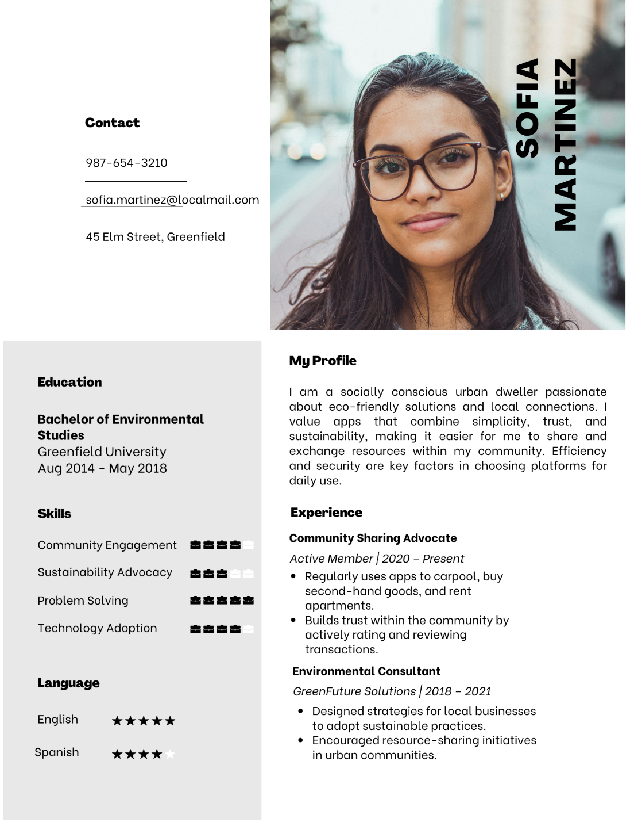

Persona #2

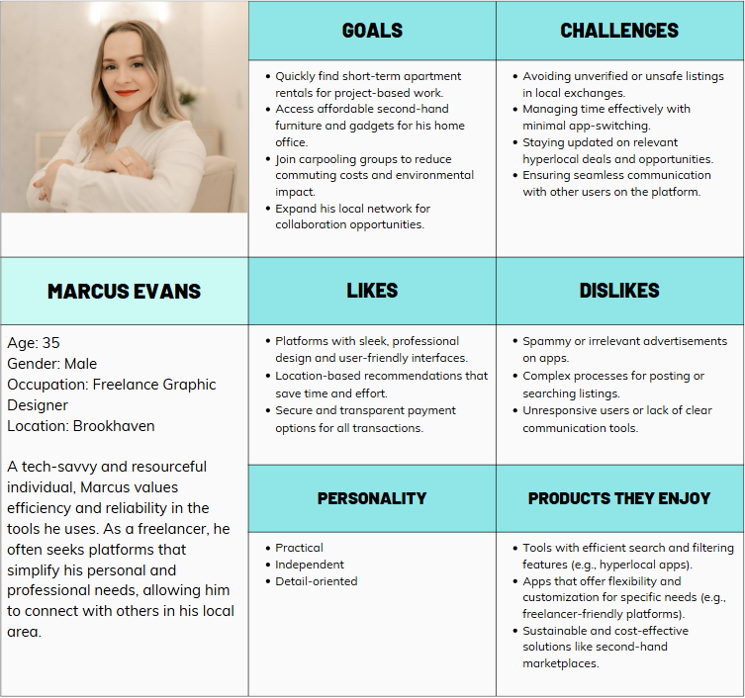

Persona #3

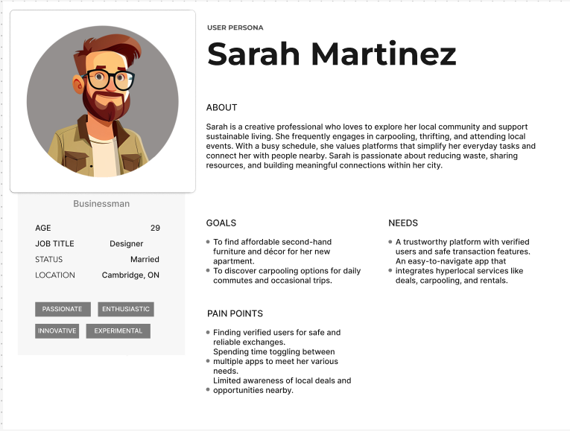

# **Use Case**

### **Use case diagram**

* **General Use case:**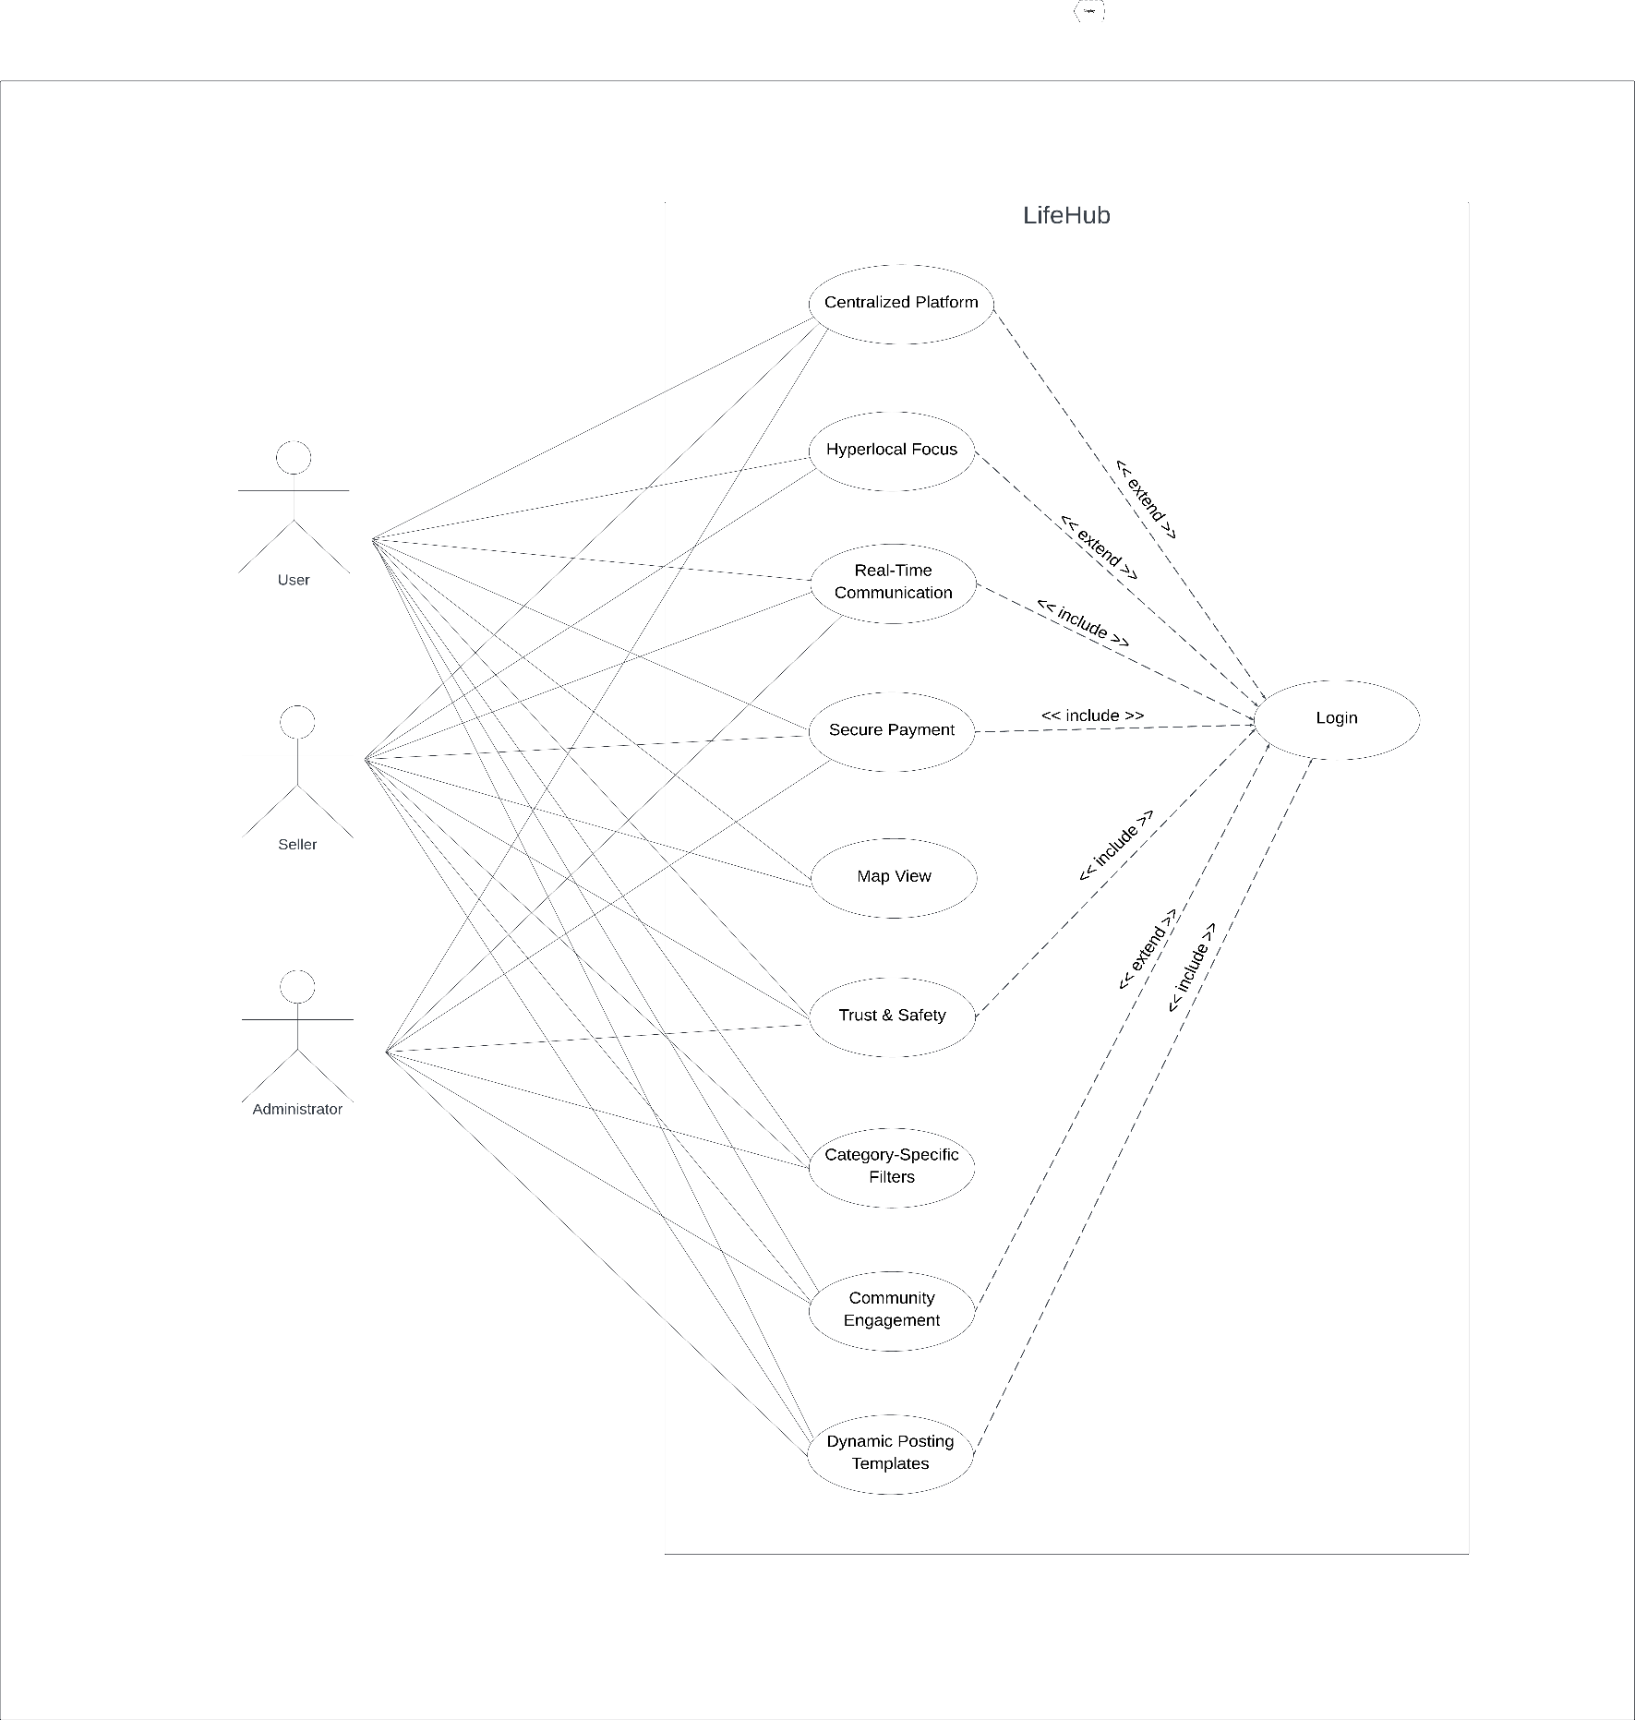This use case shows all of features of LifeHub application with 9 features and three actors(user, seller and admin). Each actor has their own features that they can interact with.
* **Centralized Platform**  
    
  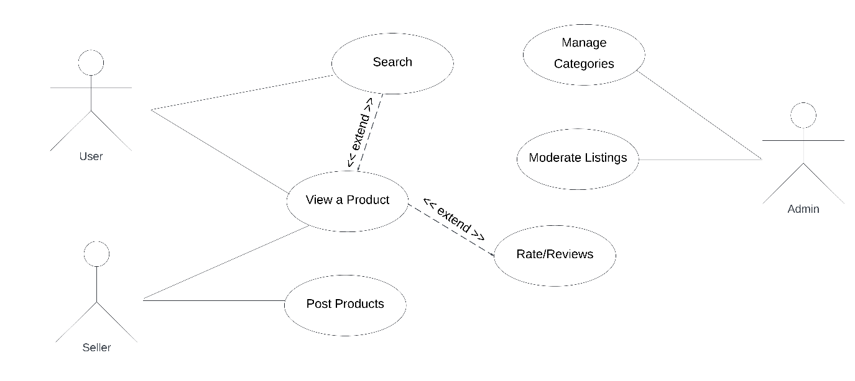

For centralized platform, users can view products, review or search for products on the application, sellers can post products, review their products. Admin will review product content, manage categories.

* **Community Engagement**

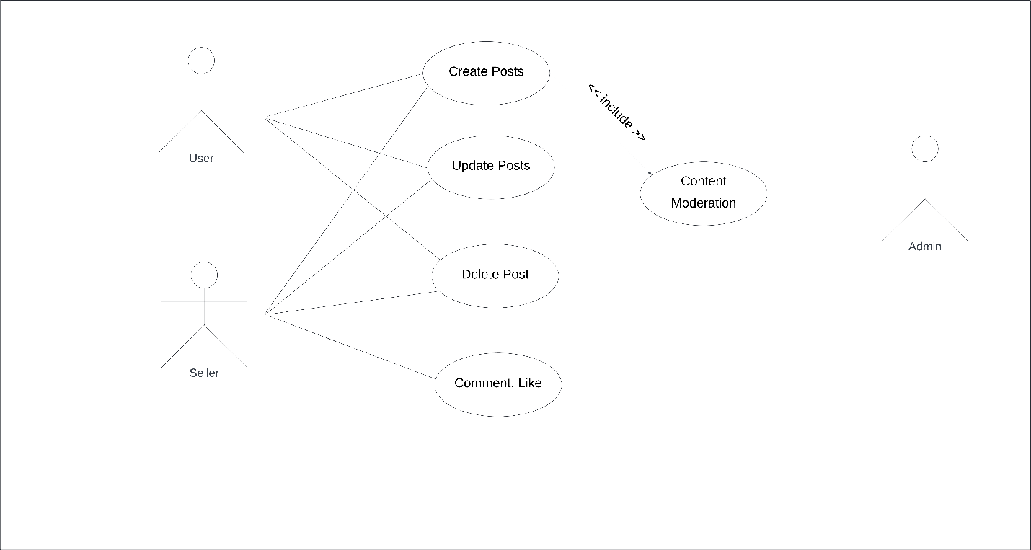

Users and sellers can post, update, delete their posts, and they can comment or like their own and other people's posts. Admins can moderate the content of posts by approving or warning and deleting them on the community.

### **Use case description**

|  |  |  |  |  |
| --- | --- | --- | --- | --- |
| UC Name | **Centralized Platform** | | | |
| Brief description | A section for students to get answers, browse FAQs, and connect with admins or employers | | | |
| Actors | User, Seller, Administartor | | | |
| Normal Flow of Events | User | Seller | Administrator | System |
|  |  |  | 1. Admin logs in and manage categories | 1. System stores the categories |
|  |  |  | 1. Admin can moderate all the postings and listings |  |
|  |  | 1. Seller logs in and post products or services |  | 1. System stores the postings |
|  | 1. User searches for a product or service |  |  | 1. System shows matching products or services from database |
|  | 1. User selects a product or service from the list |  |  | 1. System displays detailed information |
|  | 1. User can rate or review the selected product or service |  |  |  |

|  |  |  |  |  |
| --- | --- | --- | --- | --- |
| UC Name | **Community Engagement** | | | |
| Brief description | A section for students to get answers, browse FAQs, and connect with admins or employers | | | |
| Actors | User, Seller, Administrrator | | | |
| Normal Flow of Events | User | Seller | Administrator | System |
|  | User can create posts | Seller can create posts | Admin can moderate the contents | Systems stores all the contents according to the preset algorithm |
|  | User can update the posts | Seller can update the posts |  |  |
|  | User can delete the posts | Seller can delete the posts |  |  |
|  |  | Seller can react to the posts |  | System stores all the updates and reactions |

# **Activity Diagram**

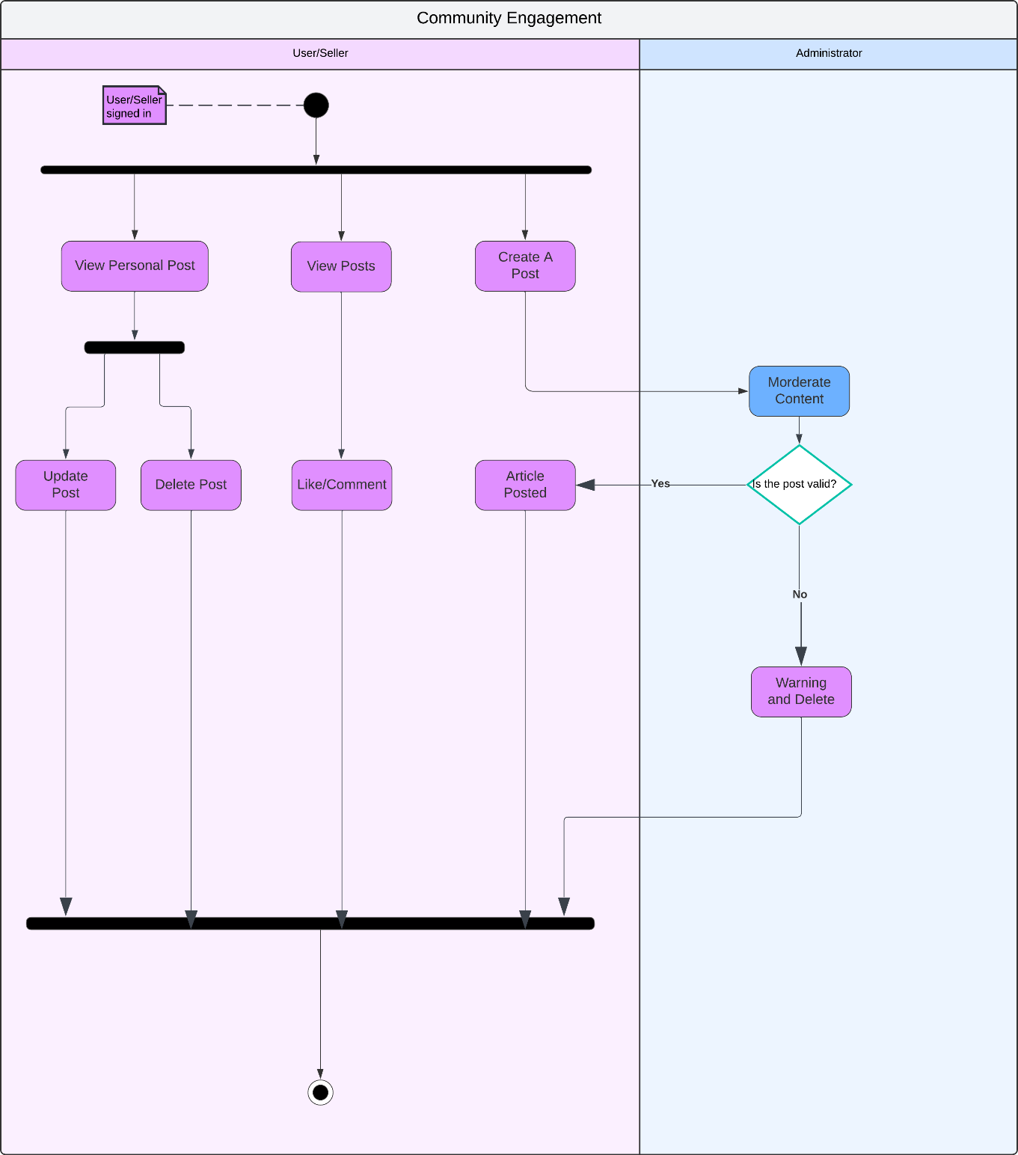

# **Entity**

1. **Entities:**

|  |  |
| --- | --- |
| Entity: Users | |
| User Id | 1 |
| First Name | Anne |
| Last Name | Hathaway |
| Username | SupperAne |
| Email | anne@gmail.com |
| Password | 827ccb0eea8a706c4c34a16891f84e7b |
| Phone | 437-519-0945 |
| Account Id | 1 |
| City Id | 1 |
| Province Id | 1 |

|  |  |
| --- | --- |
| Entity: Account Type | |
| Account Id | 1 |
| Name | User |

|  |  |
| --- | --- |
| Entity: Cities | |
| City Id | 1 |
| Name | Toronto |

|  |  |
| --- | --- |
| Entity: Province | |
| Province Id | 1 |
| Name | Ontario |

|  |  |
| --- | --- |
| Entity: Posts | |
| Post Id | 3 |
| Title | How to find a house with a reasonable price? |
| Description | I need to find a house for 2 years. |
| Approved | 1 |
| User Id | 1 |
| Created Date | 2024-10-23 |
| Updated Date | 2024-10-25 |
| Deleted | 0 |

|  |  |
| --- | --- |
| Entity: Topic | |
| Topic Id | 5 |
| Title | Renting |

|  |  |
| --- | --- |
| Entity: Post Topic | |
| Post Topic Id | 1 |
| Post Id | 3 |
| Topic Id | 5 |

|  |  |
| --- | --- |
| Entity: Comment | |
| Comment Id | 255 |
| Content | You can find a house on LifeHub |
| Comment User Id | 134 |
| Post Id | 3 |

|  |  |
| --- | --- |
| Entity: Category | |
| Category Id | 3 |
| Title | Black Friday |

|  |  |
| --- | --- |
| Entity: Products | |
| Product Id | 4 |
| Title | Airpod |
| Description | White Airpod |
| Price | $50 |
| Category Id | 3 |

|  |  |
| --- | --- |
| Entity: Admin | |
| Id | 6 |
| Username | admin230 |
| Password | 827ccb0eea8a706c4c34a16891f84e7b |

|  |  |
| --- | --- |
| Entity: Shop | |
| Shop Id | 5 |
| Name | Red Store |
| Address | 300 King George |
| City Id | 1 |
| Province Id | 1 |
| User Id | 3 |
| Entity: Shop Product | |
| Shop Product Id | 7 |
| Shop Id | 5 |
| Product Id | 4 |

|  |  |
| --- | --- |
| Entity: Payment Method | |
| Payment Method Id | 1 |
| Name | Credit |

|  |  |
| --- | --- |
| Entity: Payment | |
| Payment Id | 130 |
| Amount | $250 |
| Transaction Date | 2024-11-12 |
| Payment Method Id | 1 |
| User Id | 1 |

|  |  |
| --- | --- |
| Entity: Review | |
| Review Id | 204 |
| Description | This product is good |
| User Id | 1 |
| Product Id | 4 |

|  |  |
| --- | --- |
| Entity: Message | |
| Message Id | 1114 |
| Content | Hi, I want to buy this item with less price |
| Sender Id | 1 |
| Receiver Id | 37 |
| Sent At | 2024-11-10 23:42:45 |

1. **ERD Diagram:**

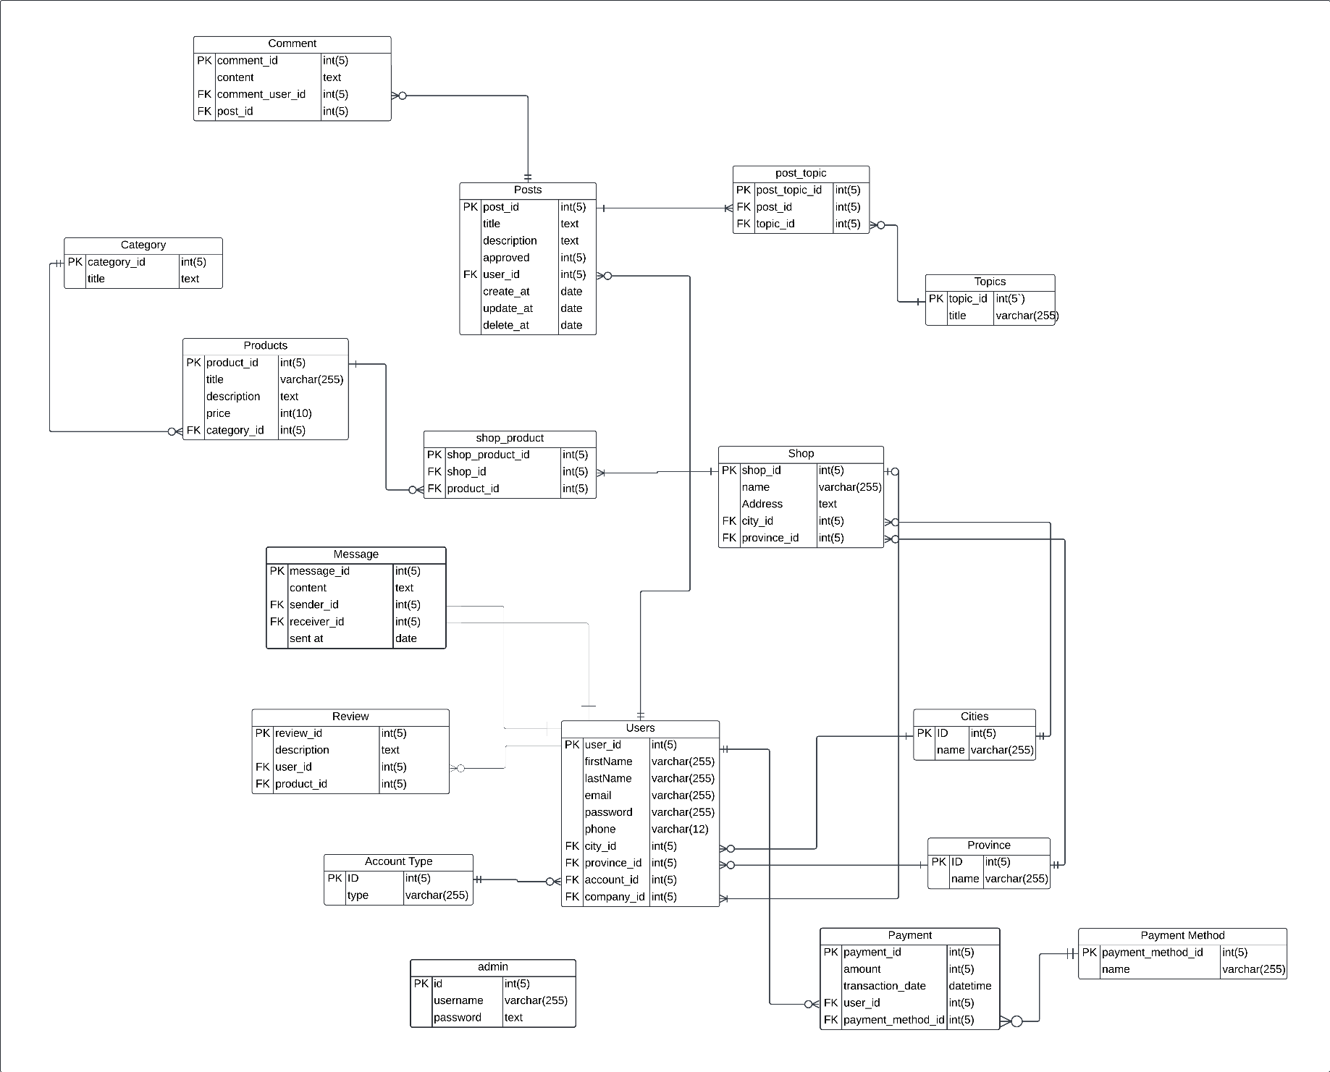

# **Content Plans**

### **1. Community Engagement (Forum)**

**Standard Header**

**Title** (Top left corner): LifeHub

**Image** (Top right corner): Profile picture of the user

**Notification Icon:** Shows the notifications

**Search Option:** Opens the search screen with suggestions

**Navigation Menu (Across the Top)**:

* **Title** (left aligned): Popular Topics.
* **View All button** (right aligned): View all discussions.
* **Navigation options** (below the title line): Different categories and popular topics.

**Main Content Panel**:

* **Title**: Popular Discussion
* **Cards** (vertically aligned list): List of popular topics with images and texts.
* **Click on a Post**: Opens the topic for discussion.
* **Create a Post**: Option for creating new post with title, description and images.
* **Discard button**: To clear the input content and go back.
* **Create button**: To create the post.
* **Response**: Displays a success screen after posting.

**Bottom bar:**

* **Home button:** To go to home page.
* **Topic button:** To view different topics.
* **News button:** To view latest news updates
* **Chatroom button:** To start a chat with the support.

### **2. Centralized Platform**

**Standard Header**

**Title** (Top left corner): LifeHub

**Image** (Top right corner): Profile picture of the user

**Notification Icon:** Shows the notifications

**Search Option:** Opens the search screen with suggestions

**Main Content Panel**:

* **Title**: Today’s Picks
* **Cards** (as a list): List of present day postings with images, price and location.
* **Click on a Post**: Opens the topic.

**Bottom bar:**

* **Home button:** To go to home page.
* **Categories button:** To view different categories.
* **Forum button:** To open the Community Engagement page.

**Chatroom button:** To start a chat with the support.

# **Class Diagram**

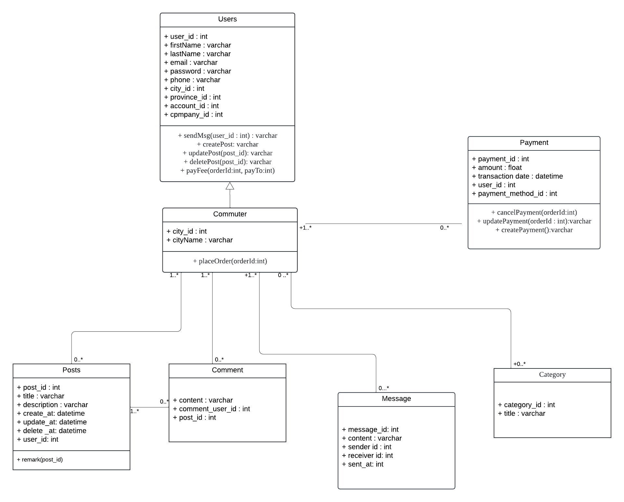

# **Prototype**

**Community Engagement (Forum):**

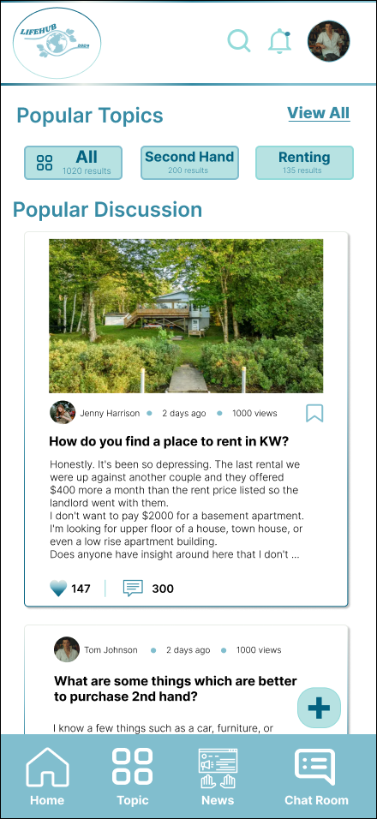 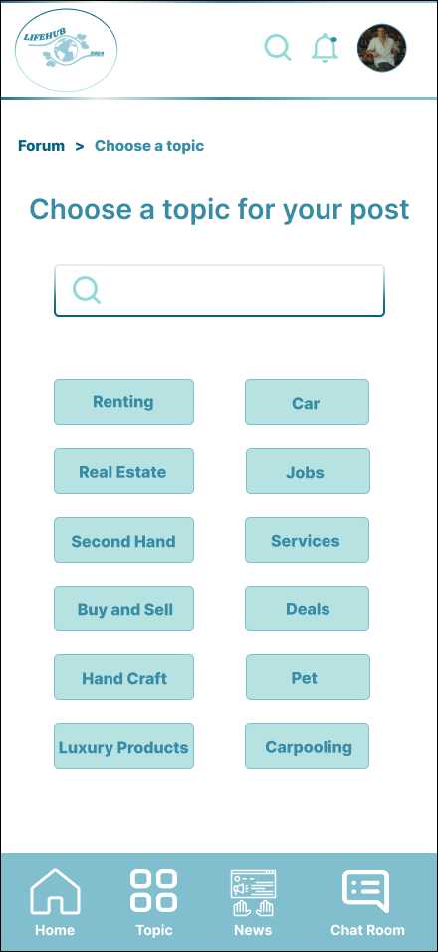

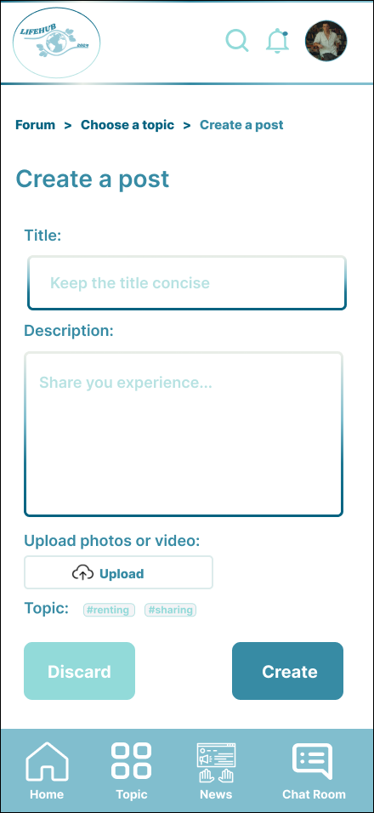 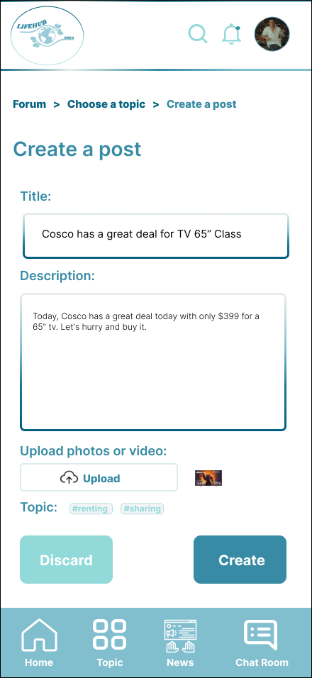

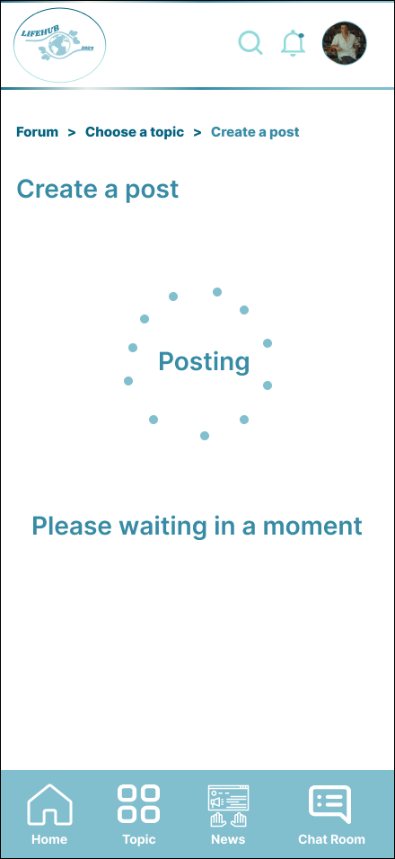 

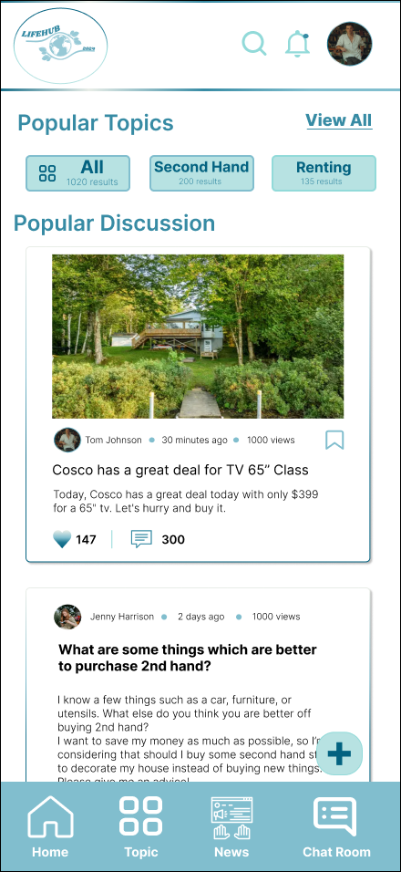

**Centralized Platform:**

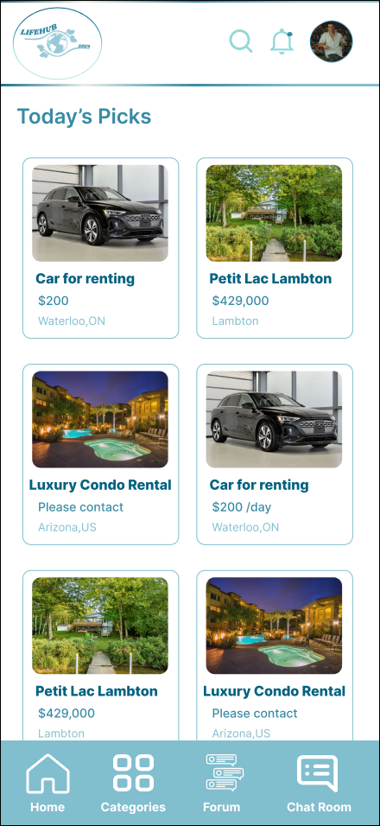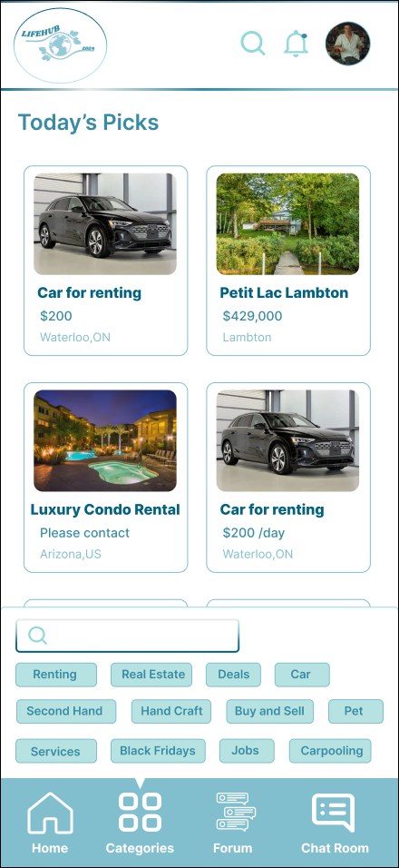

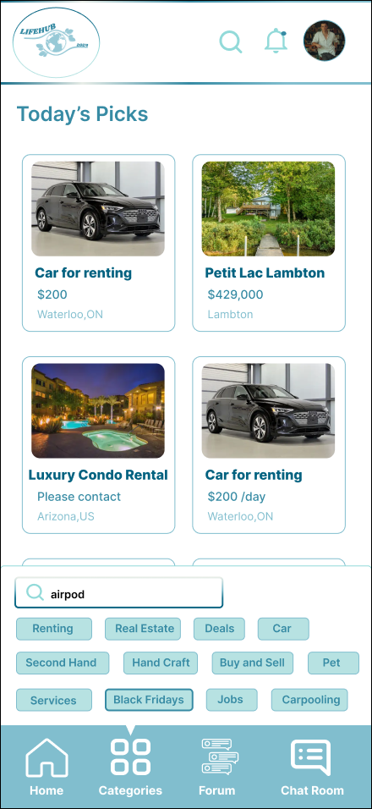

# **Agile Plan**

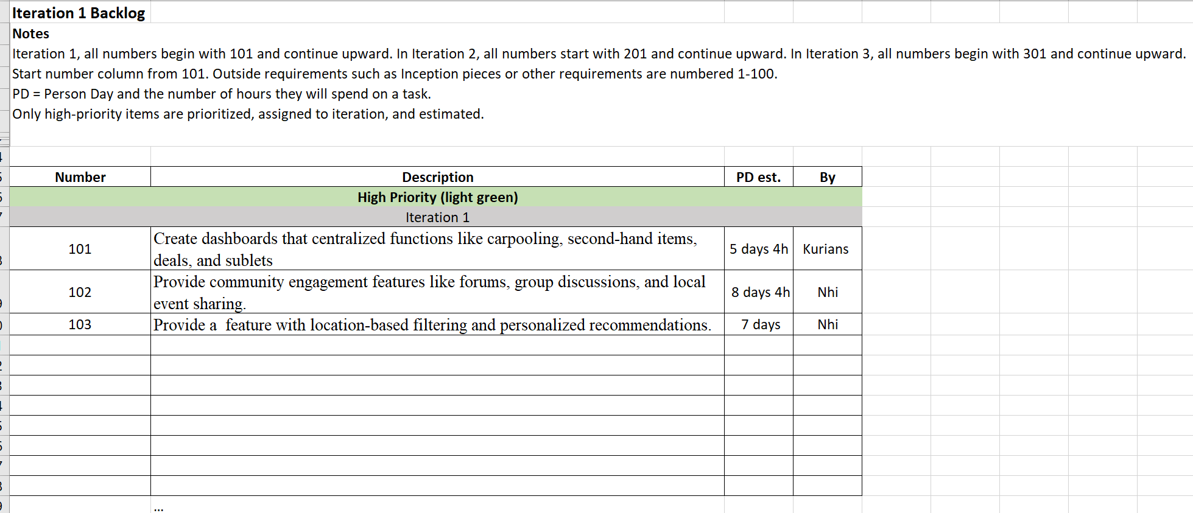

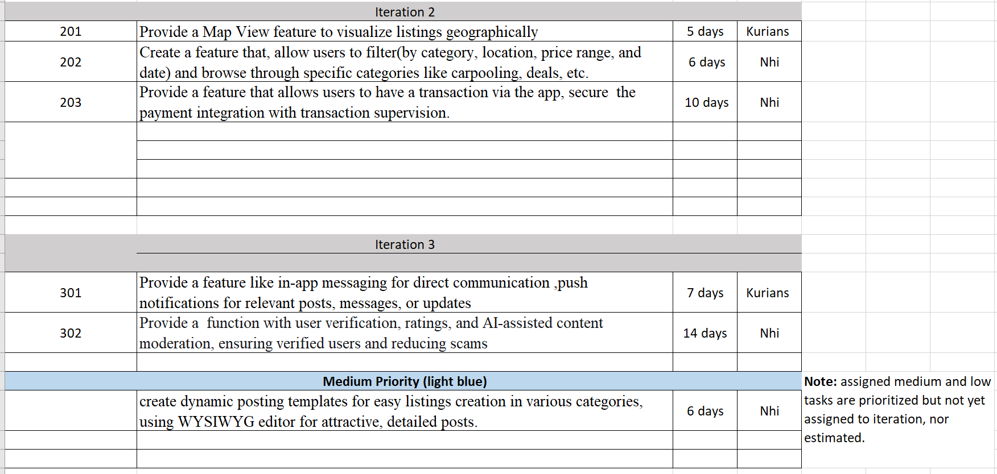



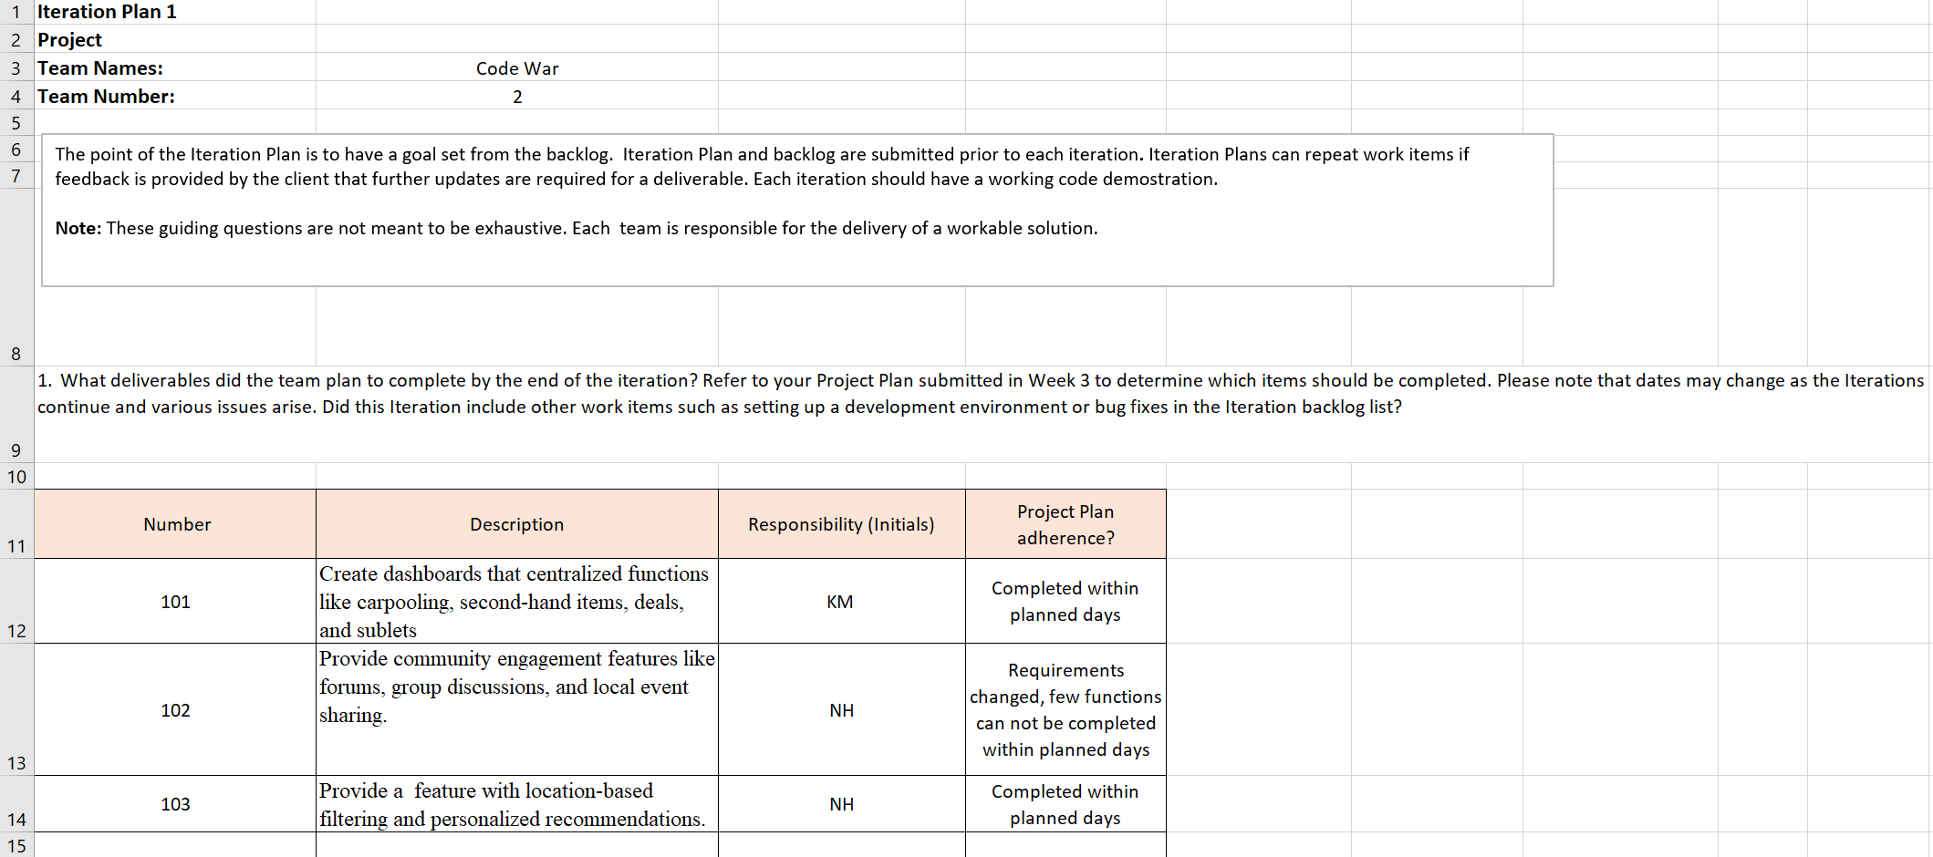

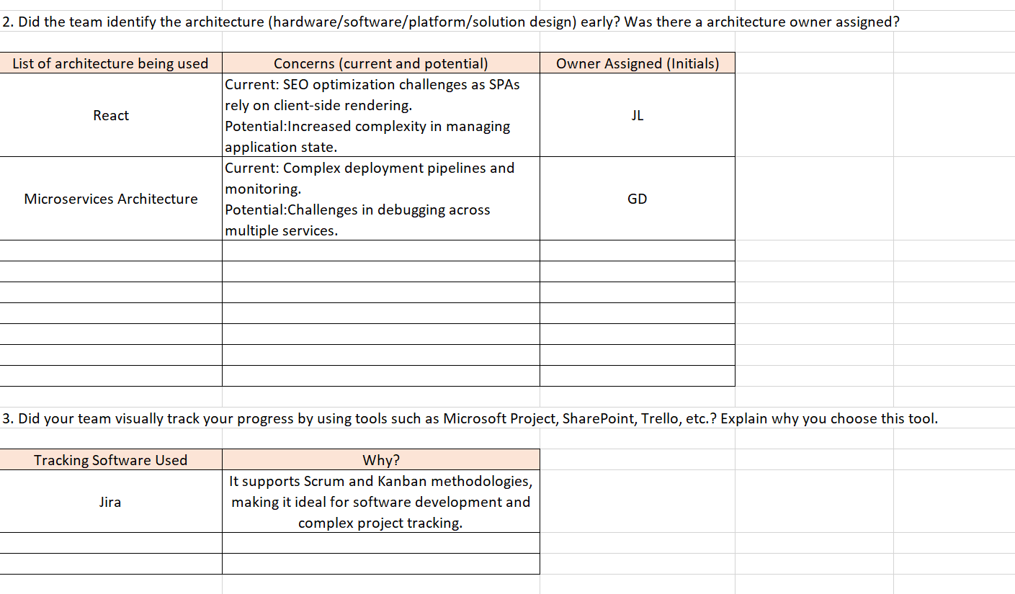

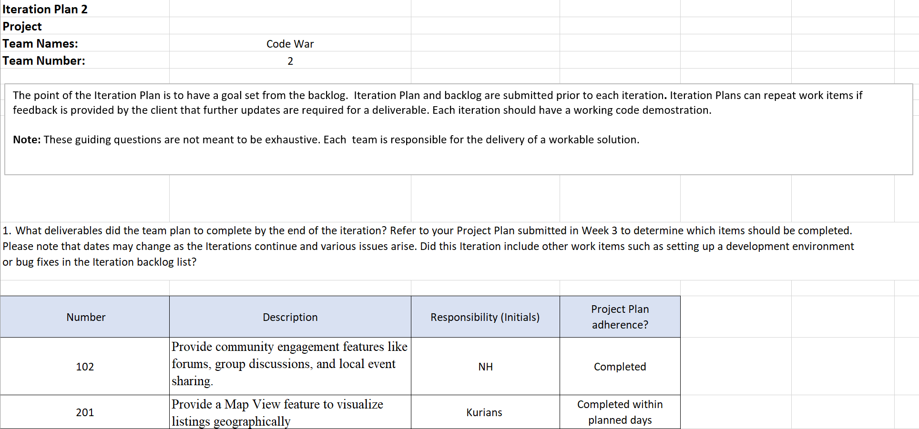

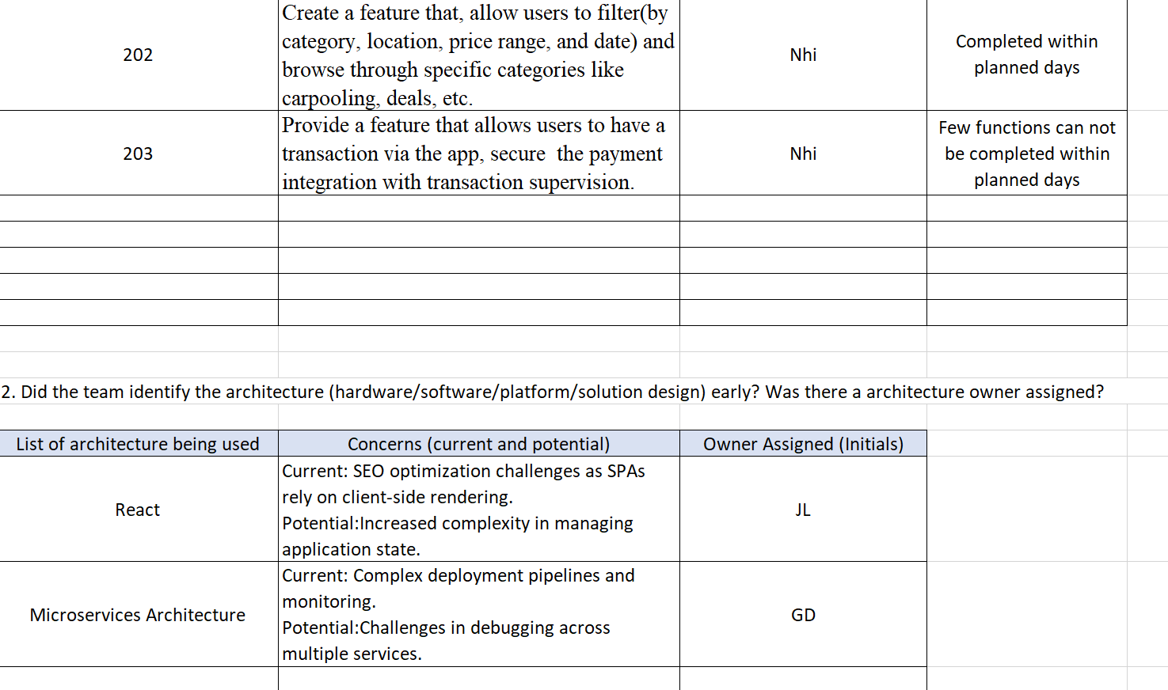

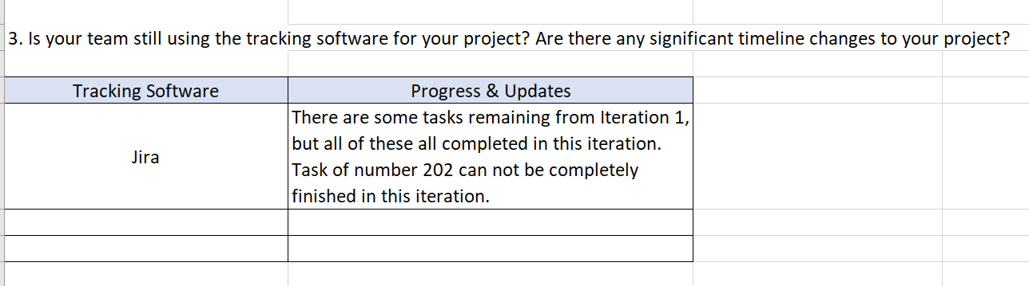

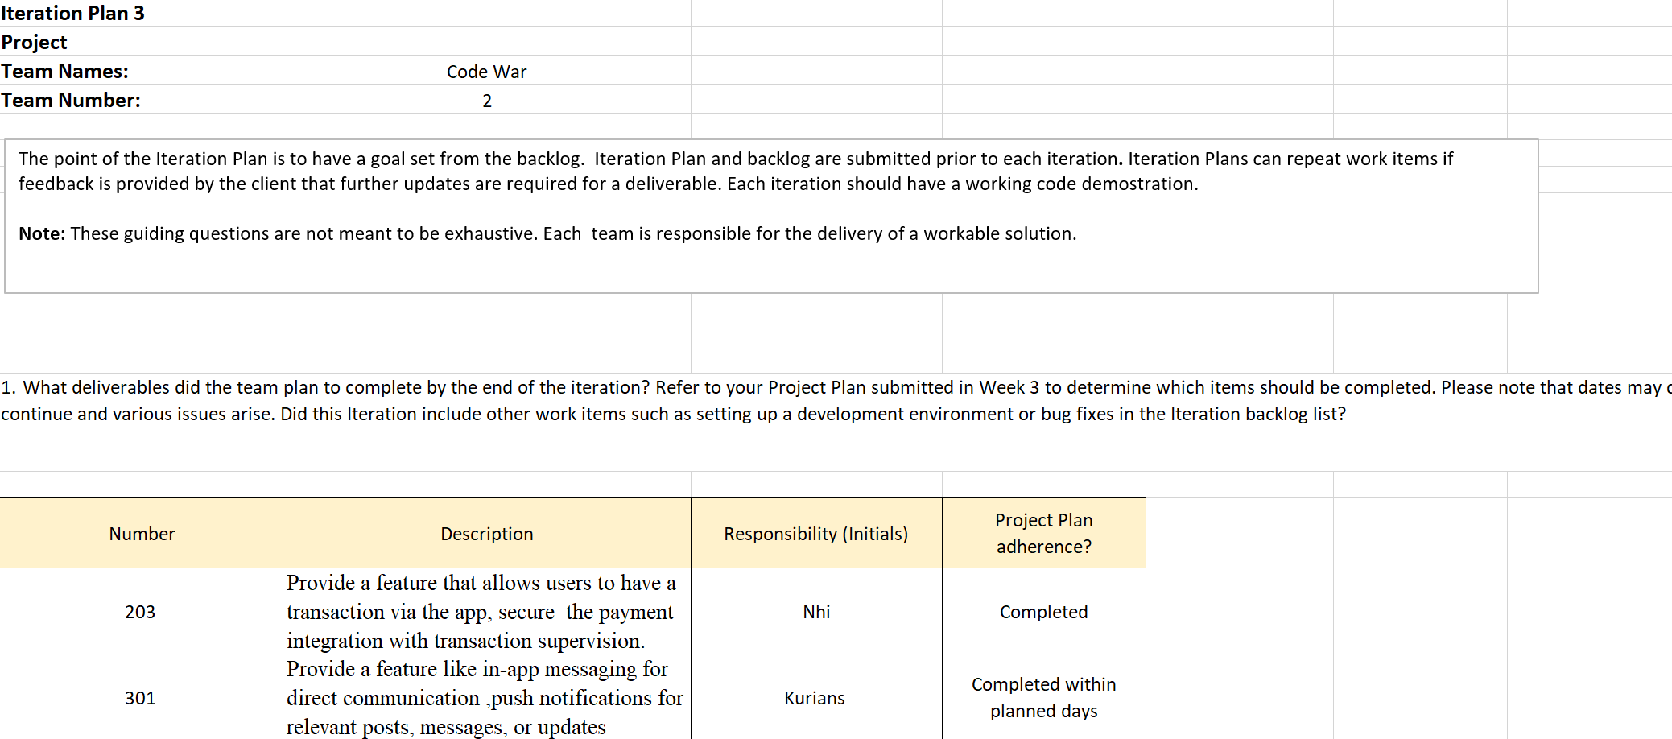

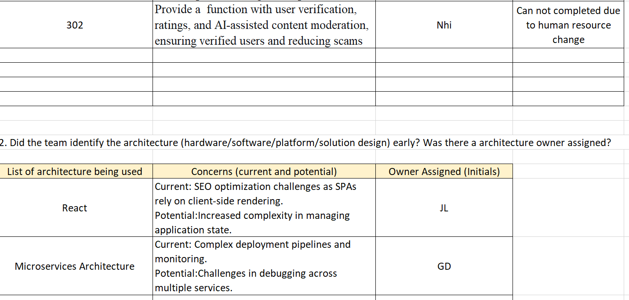

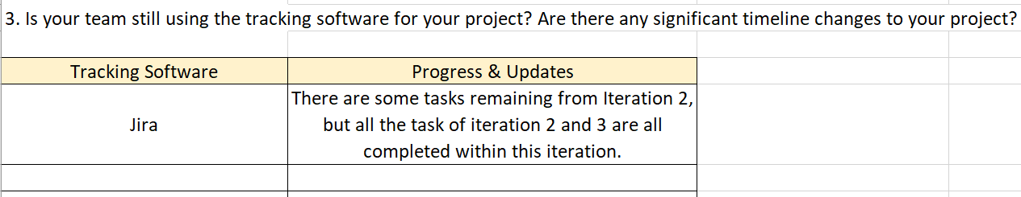

# **Conclusion**

To conclude, our unified platform is a big step toward making it easier for people to interact and take care of their daily requirements. This application gives customers a one-stop solution that saves them time and removes the headache of managing several platforms by merging carpool services, exchanging second-hand items, apartment sublets, and other community-based features. Its design places a strong emphasis on security, usability, and building trust so that users may interact with the platform with confidence and empowerment.

While community engagement tools like user profiles, ratings, and reviews guarantee transparency and promote deep connections among users, the integration of in-app payment systems with supervision further improves the security and dependability of every transaction. Our application aims to build a community where users may interact, exchange resources, and provide helpful support to one another in addition to providing services. We think this platform will become a vital resource for people looking for simplicity, convenience, and trust in their everyday interactions as we develop and enhance it further. This will allow them to save time and easily make better decisions. In addition to changing how individuals look for housing, offers, and carpooling opportunities, this software is reaffirming the value of community in the digital era.

# **Appendix**

1. "What are the challenges of entrepreneurship in small tech start-ups?"
2. “What is mob programing and pair programing”
3. "What are sustainable practices that start-ups can adopt?"